How to: Layout Config
Prepared by: Clint Lapera
Prerequisite:
- SDS requirement
  - File Layout
- Portal Access Account – must be your Authorized ECD Account
Steps
- Get the file layout from the SDS and open the specific file layout that you want to create CSV file from that layout
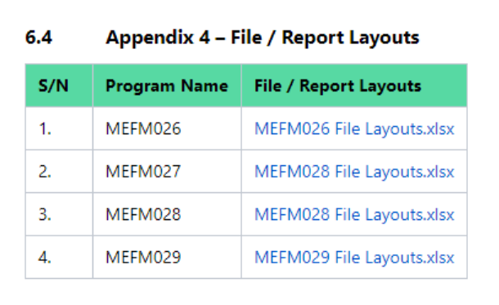
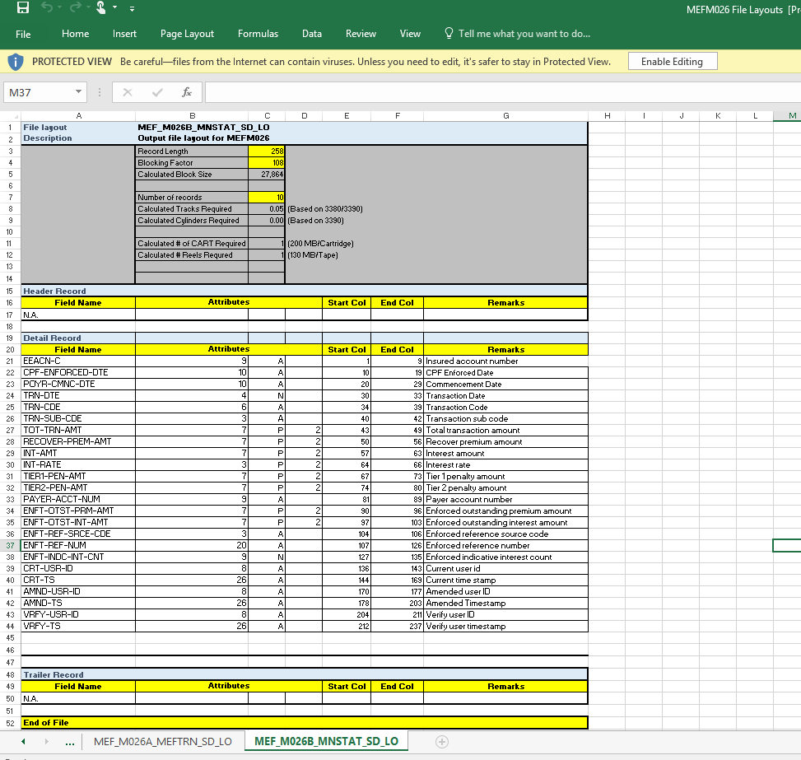

- Create a CSV file by opening a new excel file with the following standard header columns below
- Tag [CHAR (255)] – can be seen by Record Type (Header Record / Detail Record / Trailer Record) in the file layout
- [Allowed Values Y/N] – Y if Default Value is supplied, otherwise N
- Default Value [CHAR (255)] – Indicated in the file layout
- Field Name – Indicated as Field Name
- Length – Indicated in the Attributes Column
- Type [CHAR (1)] - Indicated in the Attributes Column
- Decimal Place - Indicated in the Attributes Column
- Start Col - Indicated in the Start Col
- End Col - Indicated in the End Col
- Description [CHAR (255)] - Indicated in the Remarks

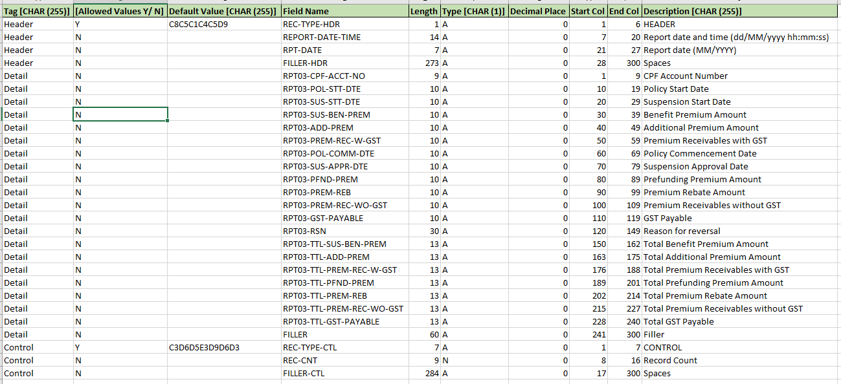

- Make sure to name the file and sheet name to the specific file layout name to be found in the SDS and save it as CSV file.
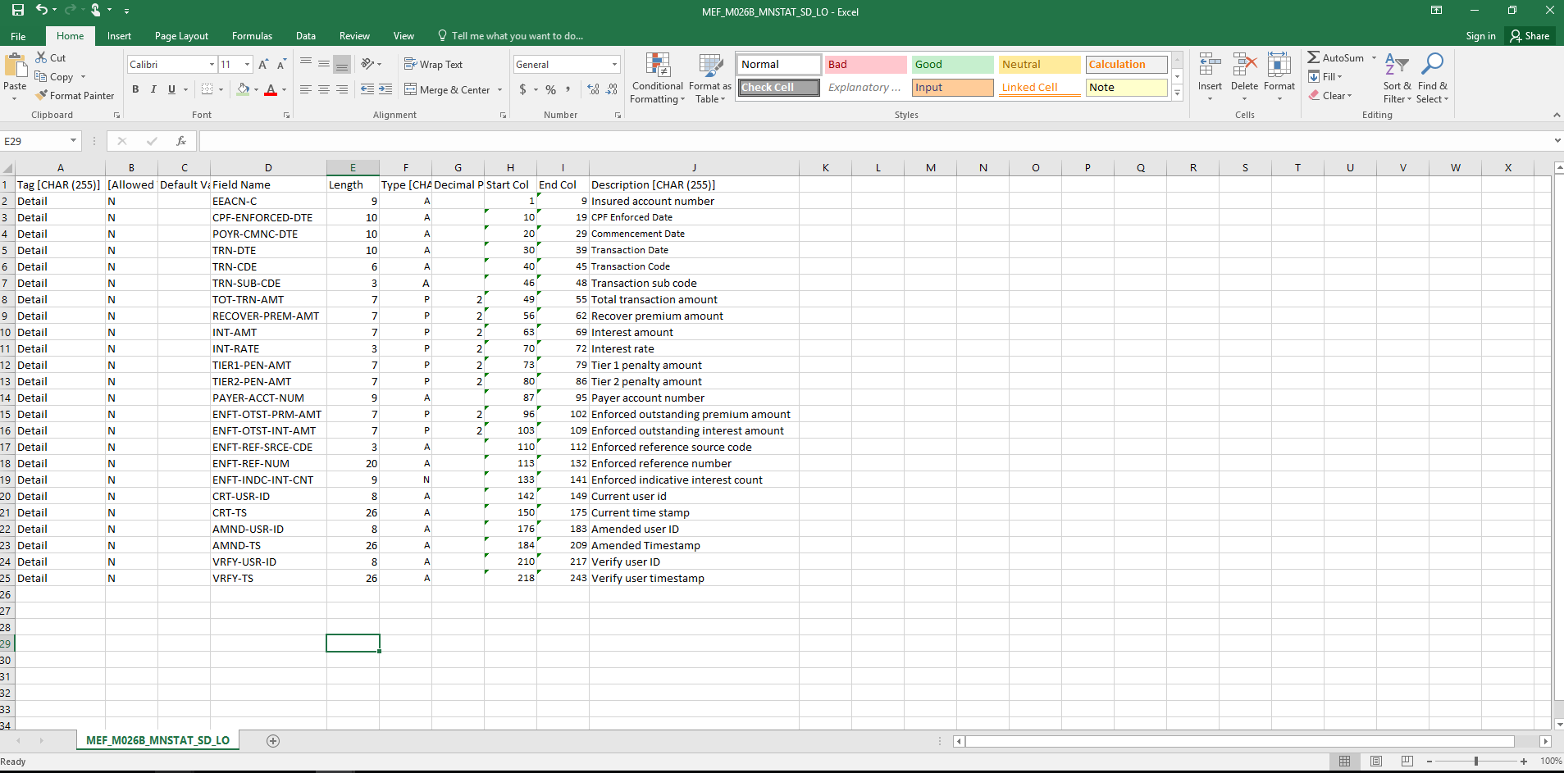

- Go to portal link (beaconobdev.cpf.gov.dg/DataConfig/ng-7-0/#/login) and use your authorized credentials. Click Admin -> Batch -> Create File Layout
Note: Authorized account must be given and requested by leads.
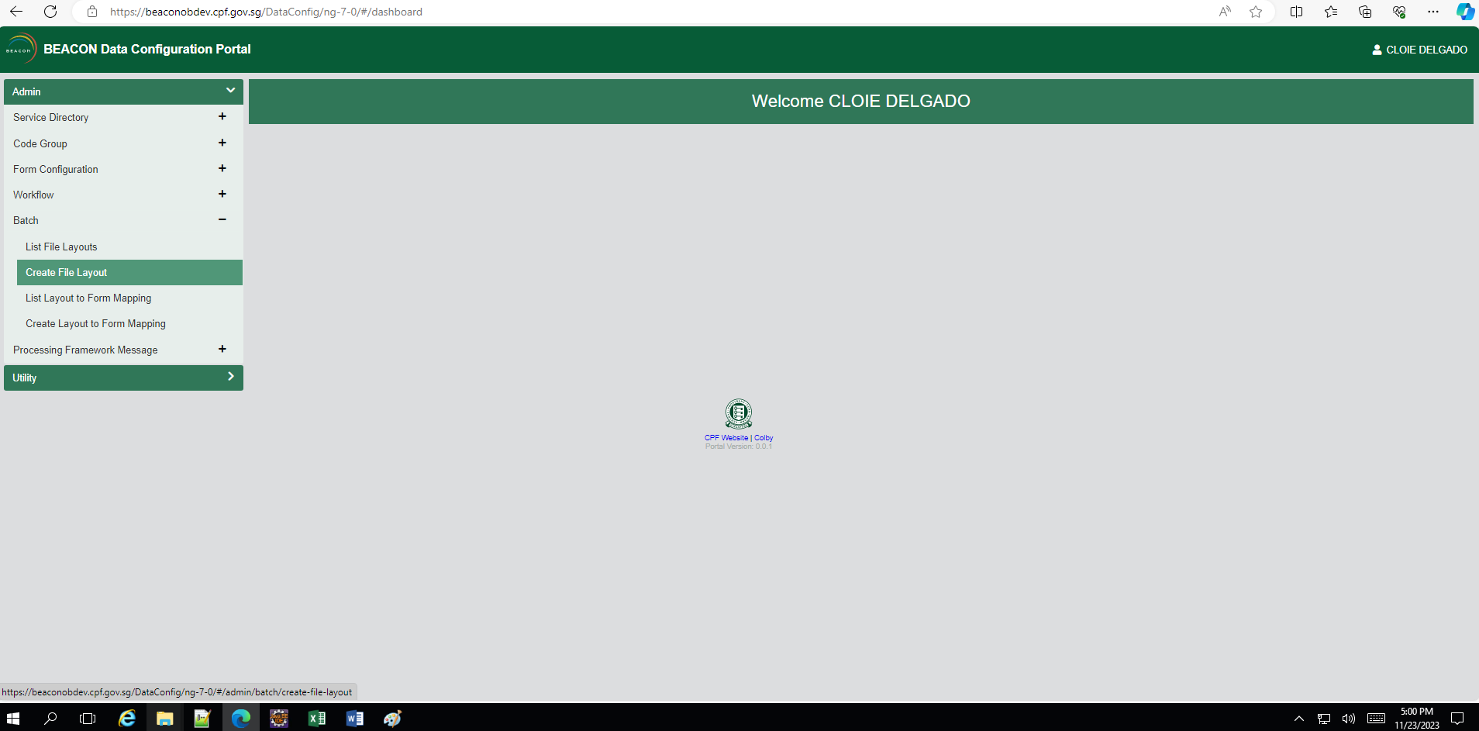
- Select Platform Type to “BEACON CICS”
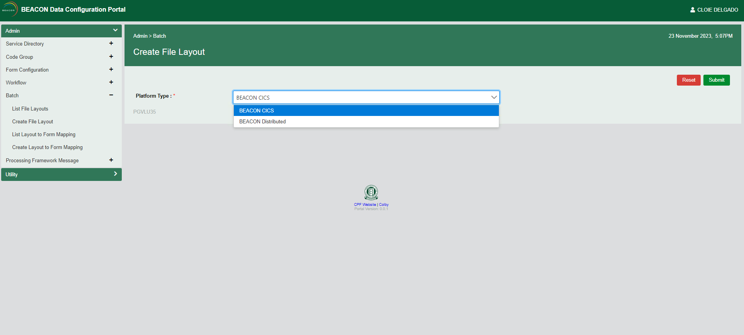
- Input the Layout Name that match to the requirement, with the following System and Choose File with the layout (.csv) created earlier and click Upload. Afterwards, click Create once it is populated the table below
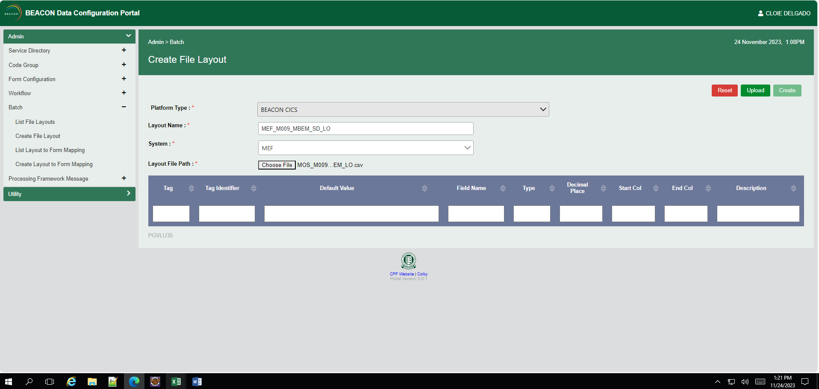

- Once created succesully, go to List File Layout and search the file layout you’ve created.
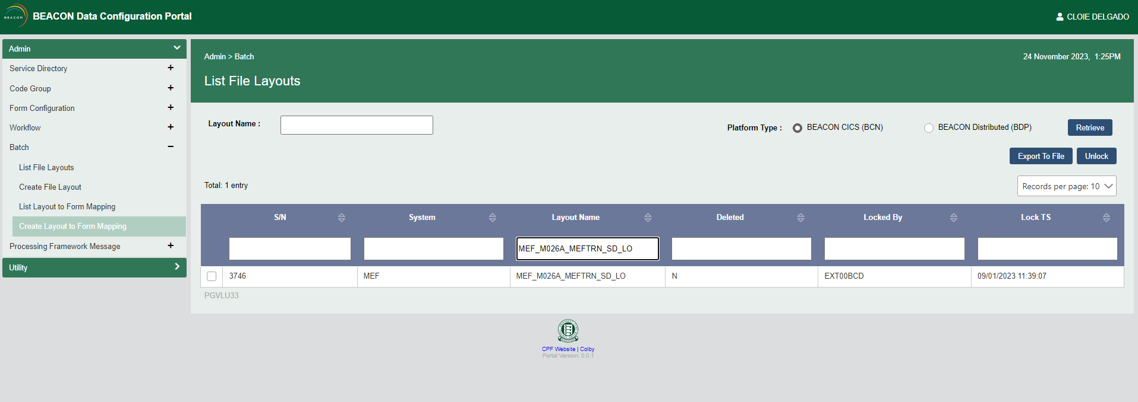
- Check the File Layout to be selected and click Export to File and should have created two SQL(s) by then.
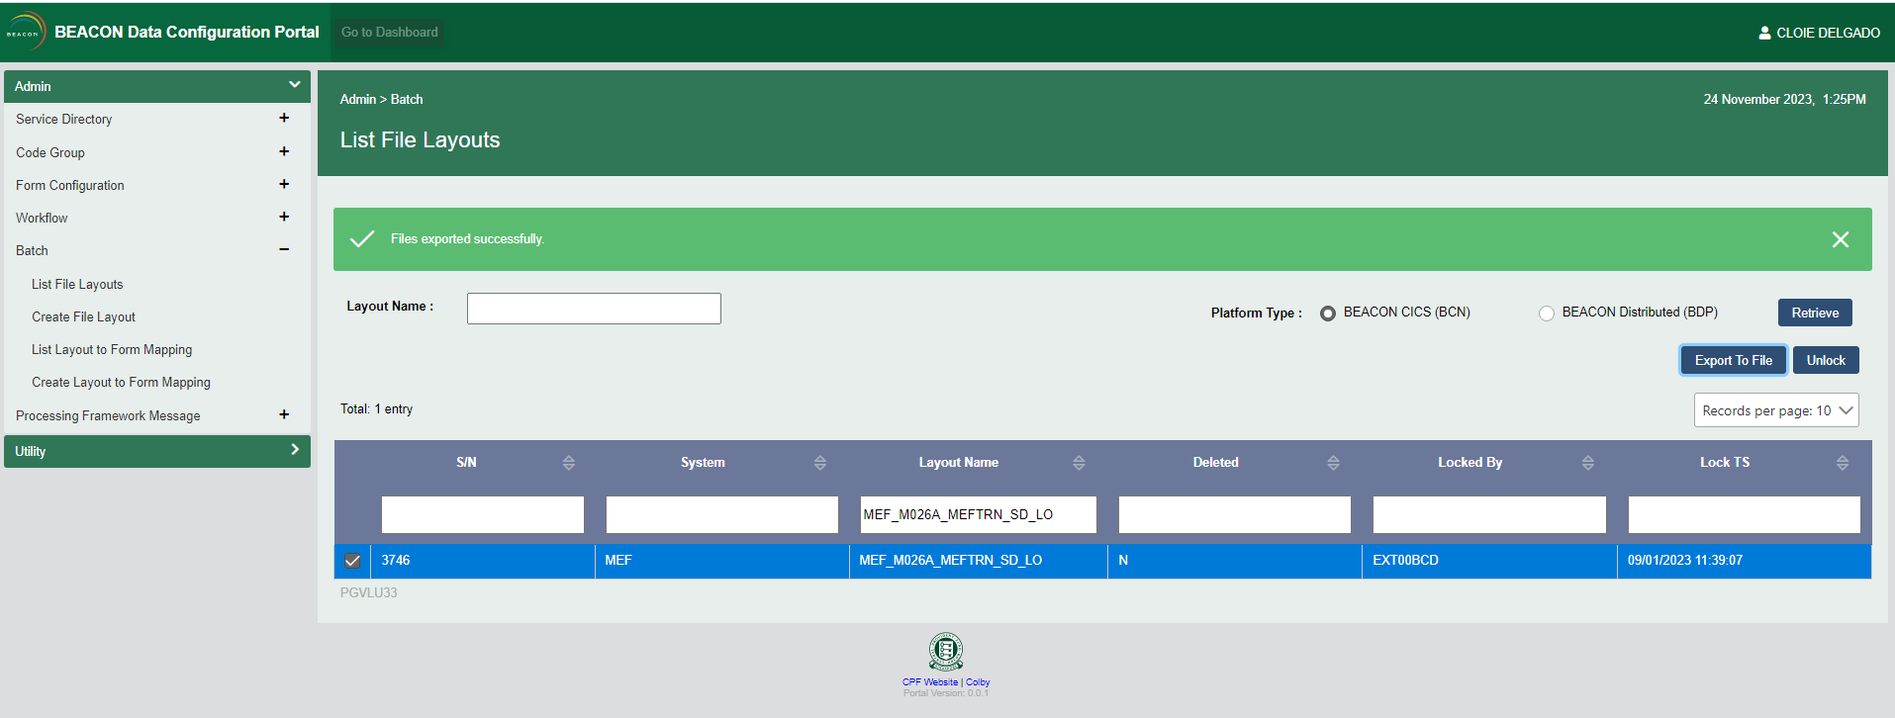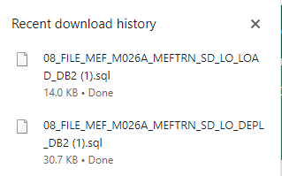
- Go to your Eclipse and find the specific stream and find the Batch File Layout subfolder with the hierarchy as follows:
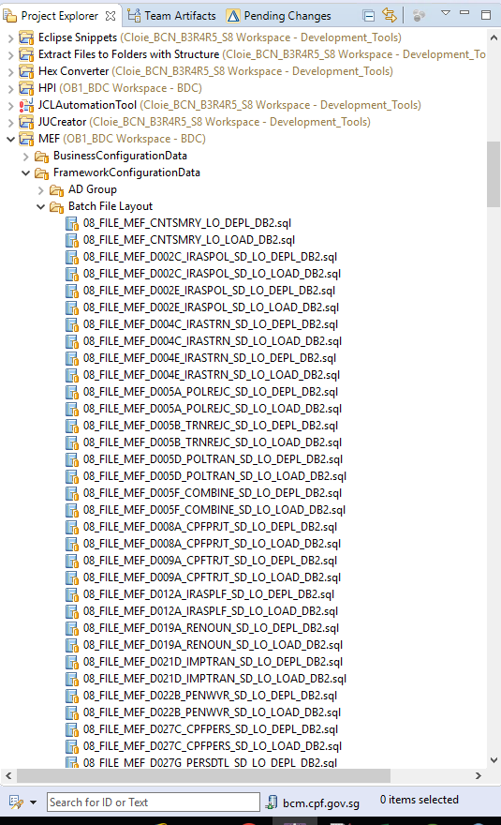
- Drag and drop the SQL files into the subfolder and submit for it approval and build Data Config workspace in Jenkins to successfully deployed your layout and wait for the restart to reflect your changes in the portal.
